**Forming the Past Continuous Tense**

**To form the verb in the Past Continuous Tense you need the correct form of ‘to be’ (was or were) and the –ing (Gerund) form of the verb.**

|  |  |  |
| --- | --- | --- |
| I  He  She  It | **was** | **reading** a book.  **watching** TV.  **going** to the cinema.  **playing** basketball.  **raining**. |
| You  We  They | **were** |

**Spelling rules**

1. Mostly the verb gets an –ing in the Present Continuous Tense. *E.g.: starting, playing, looking, skiing …*
2. If the verb is **monosyllabic**, it **ends with a vowel + consonant**, and **the vowel is short** (pronunciation) then **the consonant at the end of the verb doubles**. *E.g.: run → running*
3. If **the verb ends with –l, it doubles**. E.g.: *travel* → *travelling*
4. If the verb is **multisyllabic**, and 2nd point holds true of the last syllable then the consonant at the end of the verb doubles. *E.g.: permit, admit*
5. If the verb ends with a **mute –e**, you have to **leave it out**. *E.g.:* *make* → *making*
6. There are verbs ending with –ie, like ‘lie’. In the Gerund form the ‘ie’ changes into ‘y”.

*e.g.: lie* → *lying*

Other verbs: die, outlie, tie, untie, …etc.

**Exceptions**

There are some verbs that we don’t use in the past continuous tense. (Because they aren’t action verbs.)

*e.g.: like, love, hate, smell, seem, believe, understand, realise, belong, know, want, need, depend, suppose …*

Grammar

Past Continuous Tense

affirmative sentence

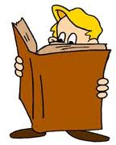

**Task 3 - Write the correct forms (Past Continuous) of the verbs on the lines from this list.**

|  |  |
| --- | --- |
| * to cook | * to sing |
| * to drink | * to wash |
| * to hide | * to watch |
| * to plant | * to water |
| * to play | * to write |

1) When I saw him he ___________________________ some milk.

2) You ___________________________ football when you broke your leg.

3) Steve ___________________________ TV when the lights went out.

4) We ___________________________ when the guests arrived.

5) Mum ___________________________ up when someone knocked at the door.

6) Nelly ___________________________ songs at the concert.

7) John and Jim ___________________________ behind a tree when they were playing hide-and-seek.

8) I ___________________________ the flowers when you came in.

9) You ___________________________ a test at 10 am yesterday.

10) They ___________________________ some seedlings yesterday afternoon.

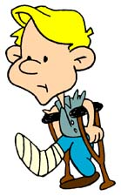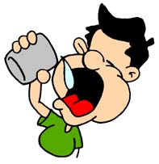

**Task 1 - Form the Gerund form of the following verbs.**

|  |  |
| --- | --- |
| 1) get → ___________________  2) open → __________________  3) take → __________________  4) travel → _________________  5) do → ____________________ | 6) lie → ____________________  7) run → ___________________  8) make → __________________  9) cut → ___________________  10) eat → ___________________ |

**Task 2 - Fill in the sentences with the correct form of the verbs in the Past Continuous Tense.**

1) They ___________________________ in the lake yesterday afternoon. (swim)

2) He ___________________________ on the coach. (sleep)

3) I ___________________________ a book. (read)

4) We ___________________________ breakfast at 7 am yesterday. (have)

5) Sarah ___________________________ the fence. (paint)

6) The kids ___________________________ the picture. (colour)

7) You ___________________________ about the accident. (talk)

8) The dog ___________________________ all last night. (bark)

9) We ___________________________ to the radio yesterday morning. (listen)

10) Pete ___________________________ his car last weekend. (wash)

**© Susan V Toth**